Student Destinations 2019
Of the 180 students that left Bishop Rawstorne C of E Academy in the summer of 2019, we have solid and confirmed data for 172, 8 students have not provided destination data – despite our best attempts to gather it.
Of the 172 students with confirmed data, 170 went on to College or Sixth Form to study either A’ levels or vocational awards, OR took a route that was linked to a college through an apprenticeship, OR have taken an independent apprenticeship of their own.
2 students moved out of area and have taken less clear routes.

The Students classed as “Other” are:
1 student at each of the following locations:
John Rigby, Reaseheath, Ashton on Mersey, Liverpool Institute of Performing Arts, Newton Rigg, Rare Studios, West Lancs and Winstanley
2 Students moved from area – 1 to the USA, 1 to Dorking – with no further details.

A LEVEL VS VOCATIONAL
166 students have provided Bishop Rawstorne with definitive course information. 94 took A levels and 72 followed a vocational route.

A Level Uptake
The table below breaks down the different subject areas that 94 students chose to take up at A level.
The 335 different A Level routes taken break down as follows.
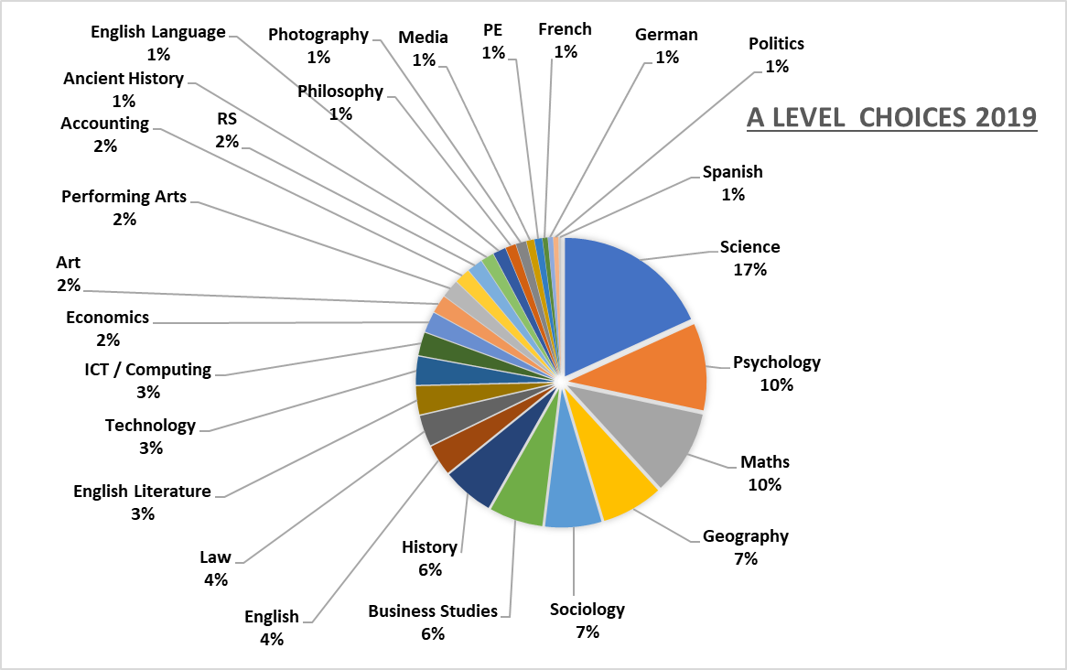

Technology encompasses 2 students taking 3D Design, 7 doing Design Engineering and 1 doing Graphics and 1 doing Textiles.

Vocational Uptake
The table below breaks down the different vocational areas that 72 students chose to follow.
