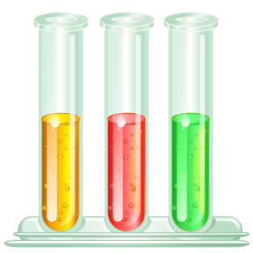
All substances should be labelled using the symbols below to show if they contain any chemicals that are hazardous.
Task 1
Use the words in the box below to label the hazard symbols.
explosives | long term health hazard | caution
flammable | oxidising | gases under pressure
toxic | corrosive | dangerous to the environment

- 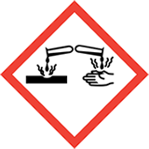 | - 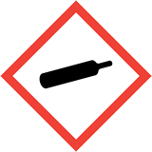 | - 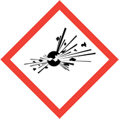
- 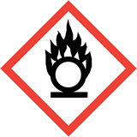 | - 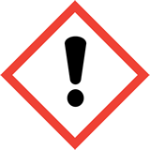 | - 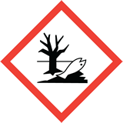
- 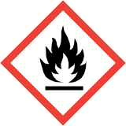 | - 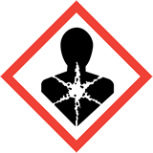 | - 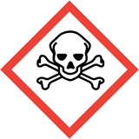
These symbols are part of the Globally Harmonised System (GHS) for labelling chemicals and were introduced into the UK recently to replace the old labelling system.
Why do you think it is important to have a global system for labelling chemicals?

Task 2
Below are statements associated with the potential hazards of some chemicals.
Consider which hazard symbols you would put in the labelling of these products. Write the numbers of the symbols from the chart above next to each statement.

1 | Kills fish in rivers
2 | Can burn a hole in wooden surfaces
3 | Causes an explosion in confined places
4 | Keep away from a naked flame
5 | Makes your eyes sting
6 | Do not swallow
7 | Can cause a mild rash
8 | Weed killer
9 | Use gloves when applying cleaner
10 | May intensify a fire
11 | Reacts violently with water
12 | Camping gas – store in a fireproof cupboard

