Name ……………………………………….…. Group ………………………….
WHAT YOU NEED TO KNOW
AQA GCSE Chemistry – C7 Organic Chemistry
The chemistry of carbon compounds is so important that it forms a separate branch of chemistry. A great variety of carbon compounds is possible because carbon atoms can form chains and rings linked by C-C bonds. This branch of chemistry gets its name from the fact that the main sources of organic compounds are living, or once-living materials from plants and animals. These sources include fossil fuels, which are a major source of feedstock for the petrochemical industry. Chemists are able to take organic molecules and modify them in many ways to make new and useful materials such as polymers, pharmaceuticals, perfumes and flavourings, dyes and detergents.

7.1 Carbon compounds as fuels and feedstock
Specification code | Expected knowledge and understanding | ☺😐☹
4.7.1.1  Crude Oil, Hydrocarbons & Alkanes | a) Crude oil is a finite resource found in rocks. Crude oil is the remains of an ancient biomass consisting mainly of plankton that was buried in mud.  b) Crude oil is a mixture of a very large number of compounds. Most of the compounds in crude oil are hydrocarbons, which are molecules made up of hydrogen and carbon atoms only.  c) Most of the hydrocarbons in crude oil are hydrocarbons called alkanes.  The general formula for the homologous series of alkanes is $C_{n}H_{2n+2}$  d) The first four members of the alkanes are methane, ethane, propane and butane.  e) Alkane molecules can be represented in the following forms:  $C_{2}H_{6}$ or  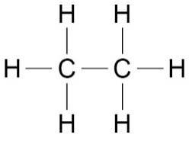  f) Students should be able to:  - Recognise substances as alkanes given their formulae in these forms.  Students do not need to know the names of specific alkanes other than methane, ethane, propane and butane.
4. 7.1.2  Fractional Distillation & Petrochemicals | a) The many hydrocarbons in crude oil may be separated into fractions, each of which contains molecules with a similar number of carbon atoms, by fractional distillation.  b) The fractions can be processed to produce fuels and feedstock for the petrochemical industry.  c) Many of the fuels on which we depend for our modern lifestyle such as petrol, diesel oil, kerosene, heavy fuel oil and liquefied petroleum gases, are produced from crude oil.  d) Many useful materials on which modern life depends are produced by the petrochemical industry, such as solvents, lubricants, polymers, detergents.  e) The vast array of natural and synthetic carbon compounds occur due to the ability of carbon atoms to form families of similar compounds.  f) Students should be able to:  - Explain how fractional distillation works in terms of evaporation and condensation.  Knowledge of the names of other specific fractions or fuels is not required.
4.7.1.3  Properties of Hydrocarbons | a) Some properties of hydrocarbons depend on the size of their molecules, including boiling point, viscosity and flammability. These properties influence how hydrocarbons are used as fuels.  b) Students should be able to recall how boiling point, viscosity and flammability change with increasing molecular size.  c) The combustion of hydrocarbon fuels releases energy. During combustion, the carbon and hydrogen in the fuels are oxidised. The complete combustion of a hydrocarbon produces carbon dioxide and water.  d) Students should be able to:  - Write balanced equations for the complete combustion of hydrocarbons with a given formula.  Knowledge of trends in properties of hydrocarbons is limited to boiling points, viscosity and flammability.
4.7.1.4  Cracking & Alkenes | a) Hydrocarbons can be broken down (cracked) to produce smaller, more useful molecules.  b) Cracking can be done by various methods including catalytic cracking and steam cracking.  c) Students should be able to describe in general terms the conditions used for catalytic cracking and steam cracking.  d) The products of cracking include alkanes and another type of hydrocarbon called alkenes.  e) Alkenes are more reactive than alkanes and react with bromine water, which is used a s a test for alkenes.  f) Students should be able to recall the colour change when bromine reacts with an alkene.  g) There is a high demand for fuels with small molecules and so some of the products of cracking are useful as fuels.  h) Alkenes are used to produce polymers and as starting materials for the production of many other chemicals.  Students should be able to:  - Balance chemical equations as examples of cracking given the formulae of the reactants and products  - Give examples to illustrate the usefulness of cracking.  - Explain how modern life depends on the uses of hydrocarbons.

7.2 Reactions of alkenes and alcohols
Specification code | Expected knowledge and understanding | ☺😐☹
4.7.2.1  Structure & formulae of Alkenes | a) Alkenes are hydrocarbons with a double carbon-carbon bond. The general formula for the homologous series of alkenes is $C_{n}H_{2N}$  b) Alkene molecules are unsaturated because they contain two fewer hydrogen atoms than the alkane with the same number of carbon atoms.  c) The first four members of the homologous series of alkenes are ethene, propene, butene and pentene.  d) Alkene molecules can be represented in the following forms:  $$C_{3}H_{6}$$  or  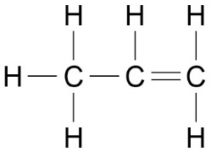  Students do not need to know the names of individual alkenes other than ethene, propene, butane and pentene.  e) Students should be able to recognise substances that are alkenes from their names or from given formulae in these forms.
4.7.2.2  Reactions of Alkenes | a) Alkenes are hydrocarbons with the functional group C=C.  b) It is the generality of reactions of functional groups that determine the reactions of organic compounds.  c) Alkenes react with oxygen in combustion reactions in the same way as other hydrocarbons, but they tend to burn in air with smoky flames because of incomplete combustion.  d) Alkenes react with hydrogen, water and the halogens, by the addition of atoms across the carbon-carbon double bond so that the double bond becomes a single carbon-carbon bond.  Students should be able to:  - Describe the reactions and conditions for the addition of hydrogen, water and halogens to alkenes  - Draw fully displayed structural formulae of the first four members of the alkenes and the products of their addition reactions with hydrogen, water, chlorine, bromine and iodine.
4.7.2.3  Alcohols | a) Alcohols contain the functional group –OH.  b) Methanol, ethanol, propanol and butanol are the first four members of a homologous series of alcohols.  c) Alcohols can be represented in the following forms:  ${CH}_{3}CH_{2}OH$ (Ethanol)  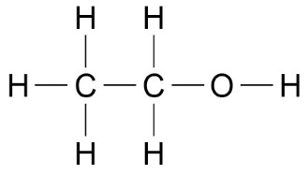  or  d) The first four alcohols are: methanol, ethanol, propanol and butanol (these are the only names students need to know!)  e) Aqueous solutions of ethanol are produced when sugar solutions are fermented using yeast.  f) Students should be able to:  - Describe what happens when any of the first four alcohols react with sodium, burn in air, are added to water, react with an oxidising agent.  - Recall the main uses of these alcohols.  - Recognise alcohols from their names or from given formulae  - Know the conditions used for fermentation of sugar using yeast  Students are not expected to write balanced chemical equations for the reactions of alcohols other than for combustion reactions.
4.7.2.4  Carboxylic Acids | a) Carboxylic acids have the functional group –COOH.  b) The first four members of a homologous series of carboxylic acids are methanoic acid, ethanoic acid, propanoic acid and butanoic acid.  c) The structures of carboxylic acids can be represented in the following forms:  ${CH}_{3}COOH$ (Ethanoic acid)  or  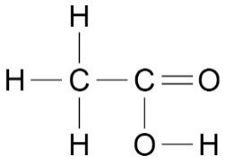  d) Students should be able to:  - Describe what happens when any of the first four carboxylic acids react with carbonates, dissolve in water, react with alcohols  - Explain why carboxylic acids are weak acids in terms of ionisation and pH  - Recognise carboxylic acids from their names or from given formulae (students are only required to know the first four names)  Students are not expected to write balanced chemical equations for the reactions of carboxylic acids.  Students do not need to know the names of esters other than ethyl ethanoate
7.3 Synthetic and naturally occurring polymers
Specification code | Expected knowledge and understanding | ☺😐☹
4.7.3.1  Addition Polymerisaton | a) Alkenes can be used to make polymers such as poly(ethene) and poly(propene) by addition polymerisation.  b) In addition polymerisation reactions many small molecules (monomers) join together to form very large molecules (polymers).  For example:  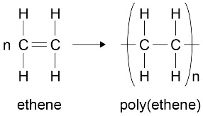  c) In addition polymers, the repeating unit has the same atoms as the monomer because no other molecule is formed in the reaction.  d) Students should be able to:  - Recognise addition polymers and monomers from diagrams in the forms shown and from the presence of the functional group C=C in the monomers.  - Draw diagrams to represent the formation of a polymer from a given alkene monomer.  - Relate the repeating unit to the monomer.
4.7.3.2  Condensation Polymerisation  (HT only) | a) Condensation polymerisation involves monomers with two functional groups. When these types of monomers react they join together, usually losing small molecules such as water, and so the reactions are called condensation reactions.  b) The simplest polymers are produced from two different monomers with two of the same functional groups on each monomer.  For example:  ethane diol  And  hexanedioic acid  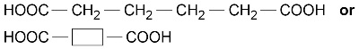  polymerise to produce a polyester:  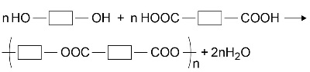  c) Students should be able to:  - Explain the basic principles of condensation polymerisation by reference to the functional groups in the monomers and the repeating units in the polymers
4.7.3.3  Amino Acids  (HT only) | a) Amino acids have two different functional groups in a molecule. Amino acids react by condensation polymerisation to produce polypeptides.  For example:  glycine is H₂NCH₂COOH and polymerises to produce  the polypeptide (-HNCH₂COO-)_{n} and n H₂O  b) Different amino acids can be combined in the same chain to produce proteins.
4.7.3.4  DNA (deoxyribonucleic acid) and other naturally occurring polymers | a) DNA (deoxyribonucleic acid) is a large molecule essential for life. DNA  encodes genetic instructions for the development and functioning of  living organisms and viruses.  b) Most DNA molecules are two polymer chains, made from four different  monomers called nucleotides, in the form of a double helix. Other  naturally occurring polymers important for life include proteins, starch  and cellulose.  c) Students should be able to name the types of monomers from which  these naturally occurring polymers are made.

